iTANZ SUCCESS STORIES

Website-Ready One-Page Content

SECTION 01 — HERO
Built around reality. Proven in operation.
Technology creates value when it understands the environment it has to work in.
Across government, utilities, healthcare and enterprise environments, iTANZ turns domain understanding into platforms, transformation and accountable operations.
Primary CTA: Explore Our Work
Secondary CTA: Talk to iTANZ
UX direction:
Premium full-width hero. Avoid generic “happy customer” imagery. Use an authentic operational environment with subtle visual references to connected systems, infrastructure and people.

Break Section

Our Philosophy
We believe meaningful transformation starts with understanding. By investing in domain expertise, next-generation capabilities and specialist talent, iTANZ engineers solutions around the realities of each organisation—not around technology for its own sake. Our philosophy is simple: understand deeply, engineer precisely and stay accountable for outcomes that continue to create value beyond go-live.

SECTION 02 — Our Values
Our Values
Principles behind every outcome.
How we think shapes how we engineer. Our principles guide the way we understand complex environments, make decisions, work with clients and remain accountable for what happens beyond delivery.

01 — Integrity
Be clear. Be accountable.
We communicate openly, make decisions responsibly and stand behind the commitments we make to our clients, partners and each other.
02 — Excellence
Engineer for what matters.
Quality is not a final checkpoint. We build precision, resilience and operational practicality into every solution from the beginning.
03 — Collaboration
Work with, not around.
The best outcomes come from shared understanding. We work closely with client teams, partners and specialists to solve problems together, not in isolation.
04 — Innovation
Progress with purpose.
We explore new technologies where they create real advantage, not because they are new. Innovation must improve how an organization operates, decides or delivers.
05 — Customer Focus
Start with their reality.
We begin with the organization, not the technology. Its industry, people, systems, constraints and ambitions shape the solution we engineer.

SECTION 03 — Behind every success

BEHIND EVERY SUCCESS STORY

Success is built into the way systems work.
iTANZ starts with the operating reality, engineers what needs to change, and stays accountable for what happens after go-live.
UNDERSTAND
Start with the operating reality.
We learn the industry, workflows, systems and constraints before recommending technology.
ENGINEER
Turn understanding into execution.
We design, build and integrate solutions around how the organisation actually needs to operate.
OPERATE
Stay accountable beyond go-live.
We support, improve and evolve the environment so value continues after implementation.

Look aisay aae gi. Ya image ma sperate blacnk apko baij raha ho
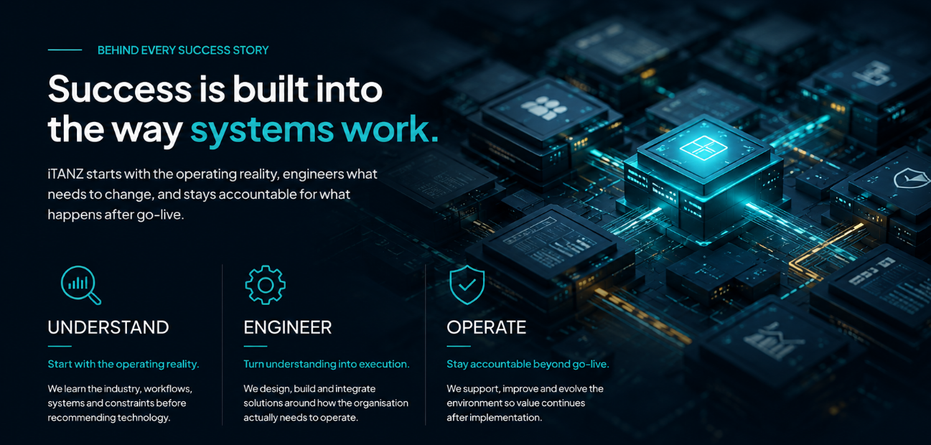

SECTION 04 — PROOF STRIP
FROM UNDERSTANDING TO OPERATION
Government
Platforms operating across Australian local-government environments.
Utilities
Delivery experience across electricity, water, district cooling and council utilities.
Healthcare
AI-native clinical automation operating in UK primary care.
UX direction:
Three compact horizontal proof statements. No fabricated percentages or vanity metrics.

Where understanding became execution.

GOVERNMENT & LOCAL COUNCILS

Connecting the systems that keep communities working.
Local government operates across finance, citizens, property, assets, workforce and field services. Fragmented systems make that complexity harder.
iTANZ brings these functions together through domain-led platforms, enterprise applications, integration and ongoing operational support.
Relevant iTANZ capability
ICP · Enterprise Applications · Integration · Data · Managed Services
Proof
Local-government platforms from iTANZ are operating across Australian council environments.
CTA: Explore Government Solutions →
Suggested visual:
Modern council operations environment with subtle platform/data connections rather than a generic city skyline.

UTILITIES & ENERGY

Connecting operations from meter to enterprise.
Utilities depend on systems that span metering, billing, revenue, customers, assets, field operations and enterprise platforms.
iTANZ combines utility-domain knowledge with billing, integration, enterprise applications, data and infrastructure capabilities to modernize these environments without losing operational continuity.
Relevant iTANZ capability
UBR · Oracle Utilities · Meter-to-Cash · Integration · IoT & Metering · Data & AI
Proof
iTANZ utility delivery experience spans council utilities, electricity and water environments, district cooling and large-scale power operations across multiple markets.
CTA: Explore Utilities Solutions →
Suggested visual:
Real utility control, field or metering environment. Avoid futuristic smart-grid clichés.

HEALTHCARE

Bringing AI into the workflow without removing human judgement.
Clinical operations require speed, context and accountability.
iTANZ applies AI and automation to healthcare workflows while keeping human review central to decisions and integrating with the systems teams already use.
Relevant iTANZ capability
OvoTech · Clinical Workflow Automation · AI · Integration · Data
Proof
AI-native clinical automation from the iTANZ portfolio is operating within UK NHS primary-care environments.
CTA: Explore Healthcare Solutions → (link to: https://ovotech.co.uk/)
Suggested visual:
Clinician or coding-review environment with technology supporting the user, not replacing them.

SECTION 05 — SUSTAINABLITY SECTION

Driving responsible progress with ESG at the core
At iTANZ, responsible progress starts with how technology is designed and delivered.
We build digital systems that strengthen efficiency, resilience and long-term value.
Our approach connects innovation with responsible use of infrastructure and resources.
We invest in people, capability and operating practices that support sustainable growth.
And we help organisations transform with greater accountability, confidence and purpose.
For us, ESG is not a separate initiative it is part of building stronger, future-ready organisations. Technology should create value today while enabling a more responsible tomorrow.

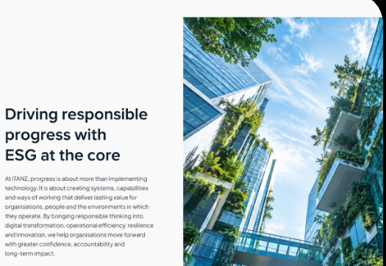

SECTION 06 — Meet the leadership

Repeat this section form home page here

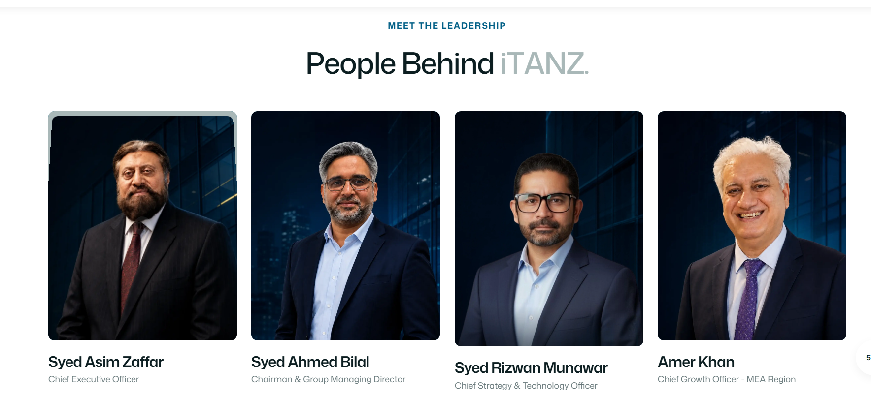

SECTION 7 — CUSTOMER CREDIBILITY

Trusted where operations matter.
iTANZ has worked across public services, utilities, healthcare, financial services and enterprise environments.
SELECTED CUSTOMER LOGOS
Recommended first-wave logo set:
Essential Energy
City of Ipswich
City of Launceston
Icon Water
City of Boroondara
City of Moonee Valley
Mornington Peninsula Shire
City of Greater Geelong
Livingstone Shire Council
K-Electric
SAB
Government of Western Australia — Department of Transport
UX direction:
Use upto 16 logos with grid of 4 logos in one row maximum at one time. Prefer a refined monochrome or controlled-brand carousel rather than a dense logo wall.
Do not attach a specific solution, product or performance result to an individual customer unless the underlying engagement is separately verified and approved.

SECTION 08 — PRODUCT CONNECTION

Products built from the industries we understand.
Our success is not separated from our product strategy. It informs it.
ICP
Local-government platform designed around the operating realities of councils.
UBR
Utility billing and revenue capability built around meter-to-cash operations.
OvoTech
AI-native clinical workflow capability designed around human-reviewed healthcare operations.
Enterprise Transformation
Data · AI · Integration · Cloud · Enterprise Applications · Managed Services
CTA: Explore Products & Solutions →
UX direction:
Four compact product/capability tiles. This section should connect proof to iTANZ IP without turning the page into a product catalogue.

SECTION 09 — SUCCESS, IN THEIR WORDS

Show three testimonial cards using modern design with each of following message and client logo

Essential Energy — Utilities
“What stood out was the team’s understanding of the operational environment before moving into the technology. They were practical, responsive and focused on making sure the solution worked in the context of the business — not just on paper.”
— Essential Energy

City of Ipswich — Local Government
“iTANZ took the time to understand how our teams work and where the complexity really sits. The engagement felt collaborative rather than transactional, and that made it much easier to work through the practical challenges along the way.”
— City of Ipswich

Thomas Jefferson University — Healthcare
“The value was in how the team connected technology with the realities of the people using it. There was a strong focus on usability, accountability and getting the details right — which matters enormously in an environment where systems support critical work.”
— Thomas Jefferson University

SECTION 10 — PEOPLE & CULTURE

Real progress is best reflected by the people who make it happen.



SECTION 10 — OUR GLOBAL PRESENCE

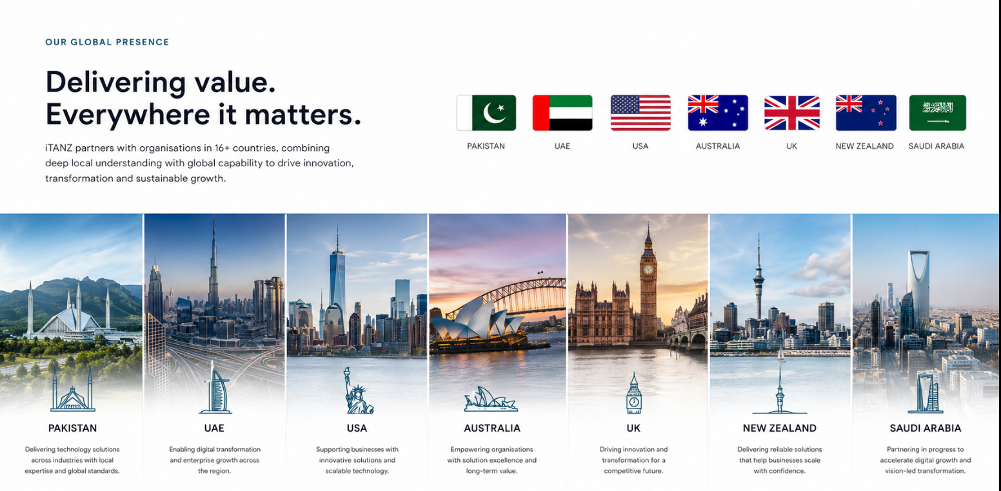

SECTION 12 — FINAL CTA

Your next success story starts with understanding.
Show us what’s holding your organisation back. We’ll uncover the friction, solve what matters, and engineer what comes next.

Primary CTA: Let’s work Together
Secondary CTA: Explore Our Solutions

For page inspirations saw this:
https://www.systemsltd.com/company-overview#accomplishments

